11/12/2019

Jun Yang LEE(Jayden)

South Metropolitan TAFE

Project Overview

Programming III AT3

# Contents

1. What data structures are you using? 1

2. Where are you using hashing techniques? 1

3. What sorting algorithm are you using how this is different from selection and bubble sort? 1

4. What search technique are you using? 1

5. What third party libraries are you using? 1

6. Where can I find the documentation for this? 2

7. A mock-up of the GUI. 2

8. What source control are you using? 2

9. What are your coding standards you are enforcing? 3

10. What tests are you going to run? 3

# 1. What data structures are you using?

I would use double-linked list for the music player as the data structures and List<string> for the music library.

# 2. Where are you using hashing techniques?

I will create a login interface just before you can access to the main application. And from there will needed a hashing techniques for password criteria.

# 3. What sorting algorithm are you using how this is different from selection and bubble sort?

The sorting algorithm going to implement in this application is Bubble Sort because the List<string> data structure built-in sorting algorithm is using Quick Sort. The differences between bubble sort and selection sort is that the bubble sort operates by repeatedly swapping the adjacent elements if they are in the wrong order while the selection sort sorts an array by repeatedly finding the minimum element from the unsorted part and placing that at the beginning of the array.

# 4. What search technique are you using?

Binary Search technique would be used in this application.

# 5. What third party libraries are you using?

The third party libraries will be Lumen Works Csv Reader to read and write data into csv files.

<https://www.nuget.org/packages/LumenWorksCsvReader/>

# 6. Where can I find the documentation for this?

All the documentation during the development of application will be upload to GitHub

<https://github.com/jaydenlee5559/Programming-III-AT3-Project>

# 7. A mock-up of the GUI.

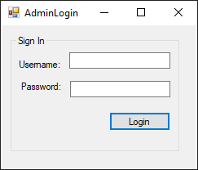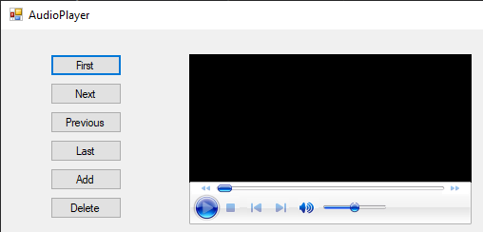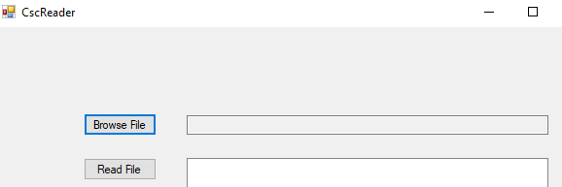

# 8. What source control are you using?

Github will be my source control platform during developing the application

# 9. What are your coding standards you are enforcing?

I would use Visual Studio Code style preferences to enforce the coding standards. Code Cleanup button at the bottom of the editor (keyboard: Ctrl+K, Ctrl+E) to apply code styles the Code Style options page.

* Code commenting
* Consistent Indention
* Capitalization Naming Rules for Identifiers

# 10. What tests are you going to run?

The undergoing tests will be overall testing all the functionalities of the application such as buttons, text boxes, login credentials, etc.